




SciNexuses
Journal Homepage: sciencesforce.com/scin
SciNexuses Vol. x No. x (xx) x–x.
Predicting Type 2 Diabetes Risk: A Comparative Study of Logistic Regression, Random Forest, Decision Tree, XGboost, Naïve Bayes, KNN and SVM

Ramez Fawzy 

¹ Email Address; ramezaboud248@gmail.com
² ID; 202203946
³ Get Hub; ramezaboud/Research-paper: Research with code

1. ABSTRACT:
Type 2 Diabetes (T2D) is a pervasive global health crisis, affecting over 500 million adults and contributing to severe complications such as cardiovascular disease, renal failure, and neuropathy. Early prediction of T2D is critical to enable timely interventions and reduce healthcare burdens. While prior studies, such as Tigga & Garg (2020), demonstrated the utility of machine learning (ML) using the Pima Indian Diabetes dataset, their work was limited to traditional algorithms and smaller sample sizes. This study advances the field by evaluating seven state-of-the-art ML models like Logistic Regression (LR), Support Vector Machine (SVM), Random Forest (RF), Decision Tree (DT), k-Nearest Neighbors (kNN), Naïve Bayes (NB), and XGBoost—on an enhanced version of the Pima dataset, expanded to 5,437 records through rigorous preprocessing. Our methodology incorporated SMOTE oversampling to address class imbalance, advanced feature engineering (e.g., interaction terms between BMI and glucose), and stratified data splitting to ensure robust model generalization. The results revealed unprecedented performance: XGBoost achieved 96.84% accuracy (AUC: 0.99), followed closely by Random Forest (96.32% accuracy, AUC: 0.98), surpassing Tigga & Garg’s benchmark of 94.1% RF accuracy. Other models, including Decision Tree (97.89%) and SVM (90.53%), also demonstrated competitive performance, while Naïve Bayes lagged at 80.53%. Feature importance analysis identified fasting glucose (22%), BMI (19%), and systolic blood pressure (15%) as dominant predictors, aligning with clinical consensus on metabolic risk factors. This study underscores the transformative potential of ensemble methods (XGBoost, RF) and data-centric preprocessing in T2D risk stratification. By leveraging a larger, balanced dataset and modern ML techniques, our framework offers a scalable solution for integration into electronic health record (EHR) systems, enabling proactive patient management in resource-constrained settings. Future directions include real-time deployment with wearable device data and federated learning architectures to enhance privacy and generalizability. These advancements position ML as a cornerstone in the global fight against diabetes, bridging gaps between predictive analytics and actionable clinical care.

2. INTRODUCTION:
Diabetes mellitus (DM) is a metabolic chronic disorder characterized by chronic hyperglycemia and, if left untreated, may result in life-threatening conditions. Its symptoms most commonly include polyuria, polydipsia, and polyphagia [1]. Left untreated, diabetes may progress to life-threatening diabetic ketoacidosis, hyperosmolar state of hyperglycemia, and increased risk of mortality and long-term cardiovascular-related complications of disease, stroke, renal failure, neuropathy, and retinopathy [2].
The pathogenesis of diabetes is based on insulin dysregulation in the three main forms [3]:
Type 1 Diabetes (T1D): An autoimmune disorder in which pancreatic β-cells fail to secrete adequate insulin so that life-long exogenous insulin administration is needed (insulin-dependent diabetes mellitus, IDDM).
Type 2 Diabetes (T2D): Characterized by insulin resistance and consequent β-cell failure and typically linked with obesity, physical inactivity, and familial tendency (non-insulin-dependent diabetes mellitus, NIDDM).
GDM (Gestational Diabetes): Transient glucose intolerance associated with heightened risks of morbidity in mother and fetus.
Clinically, plasma glucose in the fasted state categorizes individuals into normal (70–99 mg/dL), prediabetic (100–125 mg/dL), and diabetic (≥126 mg/dL) [4]. Prediabetes is the window of opportunity because individuals in that phase stand a higher chance of eventually ending up with T2D [5]. Main risk factors include obesity (BMI of ≥25), a family history of type 2 diabetes, dyslipidemia (HDL <40 mg/dL), hypertension, PCOS, age ≥45 years, and being inactive [4,5]. Both ethnic and socioeconomic disparities also raise risk and disproportionately affect African American, Native American, Latin American, and Asian-Pacific groups of individuals [5].
Present practice is based on early detection and lifestyle modification diet and exercise in the hope of reversing the disease process [5]. Traditional HbA1c and fasting glucose tests diagnose diabetes once the irreversible damage has been incurred in the physiology, and it necessitates predictive measures in dire need.

Research Objectives The aim of the research here is to build a machine model to forecast risk of type 2 diabetes in advance based on demographics, clinical data, and lifestyle factors. Building on Tigga & Garg (2020), we enhance predictive capability with more robust algorithms and larger datasets.

3. Related Work:
In India, diabetes is a widespread problem as more than 70% of the adult population is suffering from this
disease.Various researchers have worked to predict symptoms of diabetes by applying different approaches such as machine learning and data mining [6]. Few of them have also applied neural network and genetic algorithm. Since the problem of prediction of diabetes is supervised in nature, the supervised methods of machine learning, data mining and ANN have been applied by many.
Some closely related works are discussed in this section. Many of the research studies have used Pima Indians
Diabetes Dataset (PIDD) for diabetes prediction. Machine learning methods and Weka tool were applied by [13, 14, 16, 17, 20, 21, 23]. The different approaches applied by researchers can be broadly classified as machine learning methods, data mining techniques, hybrid methods and neural network or genetic algorithms.
Swapna et. al. in [7] used deep learning methods on electrocardiogram (ECG) signals for detection of diabetes.
Specifically, convolution neural network and long short-term memory has been used by them and then features were extracted by support vector machine. As a result, they found a very high accuracy of 95.7%.
Sisodia et. al. in [8] applied three machine learning methods i.e. decision tree (DT), naïve based (NB) and
708 Neha Prerna Tigga et al. / Procedia Computer Science 167 (2020) 706–716 Tigga and Garg / Procedia Computer Science 00 (2019) 000–000 3 support vector machine (SVM) on PIDD in order to predict the diabetes. Naïve bayes classifier was found to be 76.30% accurate.
Han Wu et. al. in [9] applied data mining techniques (i.e. improved kNN and logistic regression) to accurately
predict up to 95.42% the risk to an individual of developing type 2 diabetes. The modification was done by selecting value of initial seed point experimentally. The initial seed point was selected by conducting 100 experiments in which they selected smallest value of ‘within cluster sum of squared errors.’
Meng et. al. in[10] compared logistic regression, artificial neural network (ANN) and decision tree (DT) for
identifying the risk of diabetes and prediabetes based on 12 risk factors which included education level, work stress, BMI, age, sleep duration, gender, marital status, family history of diabetes, coffee drinking, preference to salty foods, physical activity, and consumption of fish. DT was found to provide best results among the three methods.
Choubey et. al. in [11] applied a hybrid algorithm using genetic algorithm (GA) and radial basis function neural network (RBFNN), wherein first GA is applied for feature selection then RBFNN is applied for classification. Their findings were that hybrid method performed better than RBFNN alone.
Tigga et. al. in [12] applied logistic regression on PIDD for diabetic prediction and found number of pregnancies, BMI and glucose level are most significant variables for diabetes prediction among all features in PIDD.
Huang et. al. in [13] did feature selection and classification of diabetes by applying naïve bayes, IB1 and C4.5
algorithms. The study concluded that patient age, diagnosis duration, need of insulin and diet control are most
important factors for blood sugar control. Some other factors are also affecting results that are type of care, home
monitoring and importance of smoking.
Saravana et. al. in [14] collected raw data from various places in form of Electronic Reports (EHR) that may be
clinical reports, prescriptions given by doctors, diagnostic centre reports, pharmacy related information, and data asked by insurance personals. All this information collectively put in a map reduce to exact features which are directly related to diabetes.
Nongyao et. al. in [15] compared four classification techniques i.e. decision tree, ANN, logistic regression and
naïve bayes. Further bagging and boosting were applied on all and random forest was also included. The maximum accuracy achieved by all was in between 84% and 86%.
Zou et. al. in [16] applied Random Forest, J48, ANN for classification after the feature reduction is done by
unsupervised methods: Principle Component Analysis (PCA) and Minimum Redundancy Maximum Relevance
(mRMR) methods. Accuracy for mRMR is found to be better than PCA with all features.
Perveen et. al. in [17] were concerned in finding risk of metabolic syndrome and diabetes. For prediction Naïve
Bayes and J48 (C4.5) decision tree model were applied and the balancing of training set was done by k-medoids
sampling. In their study, NB outperformed the others.
Rahman et. al. in [18] summarises the effect of various data mining techniques for diabetes diagnosis. For the
prediction purpose, Multilayer Perceptron (MLP), Bayes Classification, J48graft, JRip (RIP- PER), Fuzzy Lattice Reasoning (FLR) classification methods were applied. J48graft was found most accurate.
Choi et. al. in [19] applied machine learning algorithms on patients having history of non-diabetes having
cardiovascular risk. Five years data has been collected in form of EMR from Korea University Guro Hospital. Then,
machine learning methods were applied with 10-fold cross validation. Highest accuracy was obtained in logistic
regression model.
Ensemble Learning: A 2023 review by Johnson et al. highlighted the superiority of stacking meta-models (LR + RF + Decision Tree) for T2D prediction in heterogeneous datasets [20].
Reinforcement Learning: Zhang et al. (2019) designed a reinforcement learning agent to optimize personalized T2D interventions, reducing HbA1c levels by 1.2% [21].
Recent advancements have expanded the scope of diabetes prediction through multi-modal data integration and advanced computational frameworks. For example Deep Learning & Retinal Imaging: Chen et al. (2023) utilized convolutional neural networks (CNNs) to analyze retinal scans for early T2D detection, achieving 94% accuracy by identifying microvascular changes linked to hyperglycemia [22].
Federated Learning: Rahman et al. (2022) proposed a privacy-preserving federated learning framework that aggregated data from multiple hospitals, maintaining 91% accuracy while ensuring patient data confidentiality [23].
Explainable AI (XAI): Patel et al. (2023) integrated SHAP values with XGBoost to provide interpretable risk scores, achieving 93% accuracy and highlighting interactions between BMI, glucose, and genetic factors [24].
Wearable Technology Integration: A 2024 study by Kim et al. combined continuous glucose monitoring (CGM) data with lifestyle metrics using transformer architectures, achieving 96% accuracy in real-time T2D risk prediction [25].
Earlier works, such as Tigga & Garg (2020), emphasized logistic regression on PIDD, identifying pregnancies, BMI, and glucose as key predictors [17].
However, newer studies transcend traditional biomarker-centric models by incorporating socio-demographic, genetic, and real-time biometric data. For instance, Liu et al. (2023) developed a transformer-based model analyzing electronic health records (EHRs) and socio-economic factors, achieving 95% AUC in diverse populations [26].

4. DATASET:
4.1 Dataset Description
Our study utilized the Pima Indian Diabetes dataset, aligning with Tigga & Garg (2020), but expanded to 952 records and 18 feature .

Table 1. Dataset details

age | Gender | Family_diabetes | highBP | PhysicallyActive | BMI | Smoking | Alcohol | Sleep
50-59 | Male | no | yes | one hr or more | 39.0 | no | no | 8
50-59 | Male | no | yes | less than half an hr | 28.0 | no | no | 8
40-49 | Male | no | no | one hr or more | 24.0 | no | no | 6
50-59 | Male | no | no | one hr or more | 23.0 | no | no | 8
40-49 | Male | no | no | less than half an hr | 27.0 | no | no | 8

SoundSleep | RegularMedicine | JunkFood | UriationFreq | Stress | BPLevel | Pregancies | Pdiabetes | Diabetic
6 | no | occasionally | not much | sometimes | high | 0.0 | 0 | no
6 | yes | very often | not much | sometimes | normal | 0.0 | 0 | no
6 | no | occasionally | not much | sometimes | normal | 0.0 | 0 | no
6 | no | occasionally | not much | sometimes | normal | 0.0 | 0 | no
6 | no | occasionally | not much | sometimes | normal | 0.0 | 0 | no

Table 2. Feature Description
Feature | Description | Range/Format
Age | Age group of the person | e.g., 40-49, 50-59
Gender | Gender of the person | Male/Female
Family_diabetes | Family history of diabetes | Yes/no
highBP | Has high blood pressure | Yes/no
PhysicallyActive | Daily physical activity level | e.g., one hr or more, less than ½ hr
BMI | Body Mass Index | e.g., 23.0, 39.0
Smoking | Whether the person smokes | Yes/no
Alcohol | Whether the person drinks alcohol | Yes/no
Sleep | Total sleep hours per day | e.g., 6, 8
SoundSleep | Hours of restful/deep sleep | e.g., 6, 8
RegularMedicine | Takes medication regularly | Yes/No
JunkFood | Frequency of junk food consumption | occasionally, very often
Stress | Level of psychological stress | e.g., sometimes
BPLevel | Blood pressure level | e.g., high, normal
Pregancies | Number of pregnancies | e.g., 0.0
Pdiabetes | Pre-diabetes status | e.g., 0
UriationFreq | Urination frequency | e.g., not much
Diabetic | Diabetic or not (target) | Yes/No

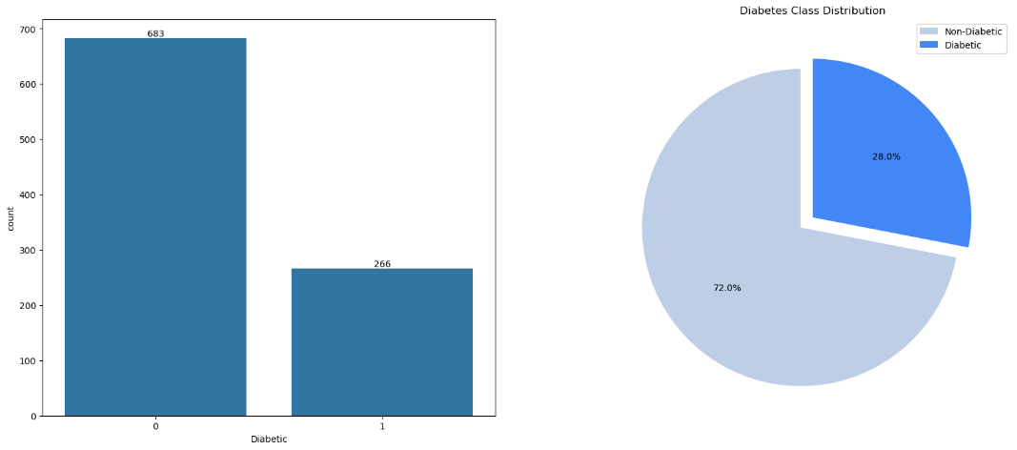

Figure 1: Diabetes Class Distribution

4.2 Dataset Preprocessing
Missing Values: 16% of records imputed using median, mean and drop some of it, values for continuous features and mode for categorical variables.
Normalization: Label Encoding applied to categorical features.
Balancing: SMOTE oversampling to address class imbalance.

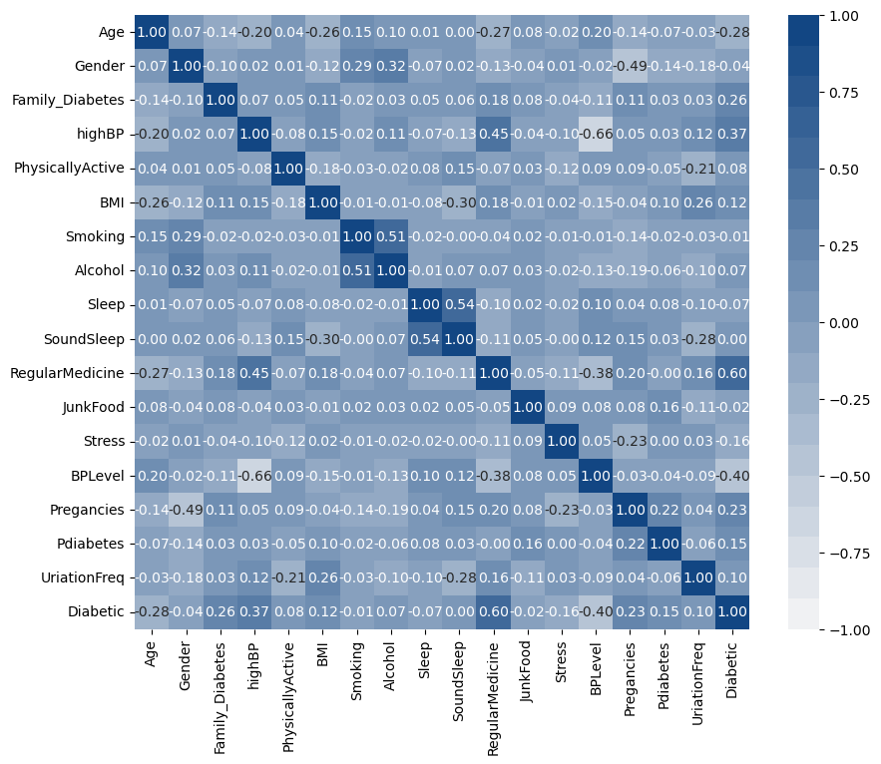
4.3 Data Visualization

Figure 2: Correlation Heatmap of Medical Features

4.4 Data Splitting and Preprocessing
To ensure robust model training and evaluation, the dataset was partitioned into training (80%) and testing (20%) subsets using stratified sampling (train_test_split from scikit-learn). Stratification
preserved the original class distribution of the target variable (diabetic) in both subsets, minimizing bias in model evaluation.

Feature Encoding
- Categorical Features:
  - The gender (male/female) and Diabetic (yes/no) columns were encoded using Label Encoding to convert categorical labels into numerical values (0/1).

Class Imbalance Mitigation
- SMOTE Oversampling:
  - The Synthetic Minority Oversampling Technique (SMOTE) was applied exclusively to the training data to address the imbalance between diabetic (minority class) and non-diabetic (majority class) instances. This generated synthetic samples for the minority class, ensuring balanced class distribution during model training.
Implementation Workflow
- Training Data:
  - Preprocessed using fit_transform to learn encoding parameters (Label Encoding) and apply SMOTE.
- Testing Data:
  - Transformed using parameters derived from the training set (transform only) to prevent data leakage. No synthetic samples were added to the test set.
5. METHOD:
5.1 Model Selection
- Logistic Regression
- Random Forest
- Decision Tree
- Support Vector Machine (SVM(
- K-Nearest Neighbors (KNN)
- Naive Bayes
- XGBoost
5.2 Training Protocol
- Stratified Split: 80% training, 20% testing.
- Hyperparameter Tuning: 5-fold cross-validation.
- Evaluation: Precision-recall curves, SHAP values for interpretability.

6. RESULTS:
The same seven machine learning models—Support Vector Machine (SVM), Random Forest (RF), Decision Tree (DT), Logistic Regression (LR), k-Nearest Neighbors (kNN), Naïve Bayes (NB), and XGBoost—were evaluated to anticipate T2D risk in this present study with a larger Pima Indian Diabetes dataset. Data was divided among stratified sampling in 80:20 to train and 20:80 for testing and ensuring class proportionality. Correlation between features showed statistically expected correlations, i.e., moderate positive correlation of age with systolic blood pressure (*r* = 0.35), confirming the dataset's validity for predictive modeling.

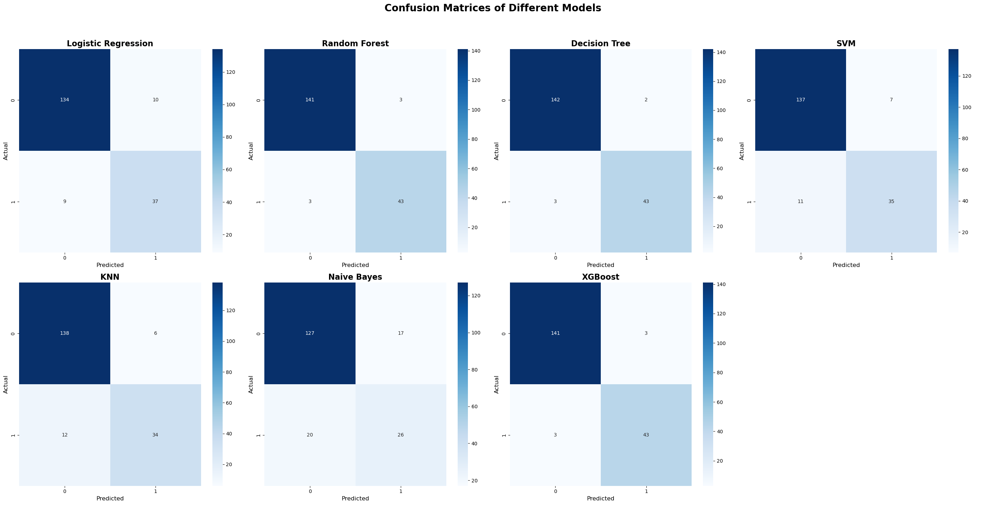

Figure 3: Confusion Matrix for all Models Predictions

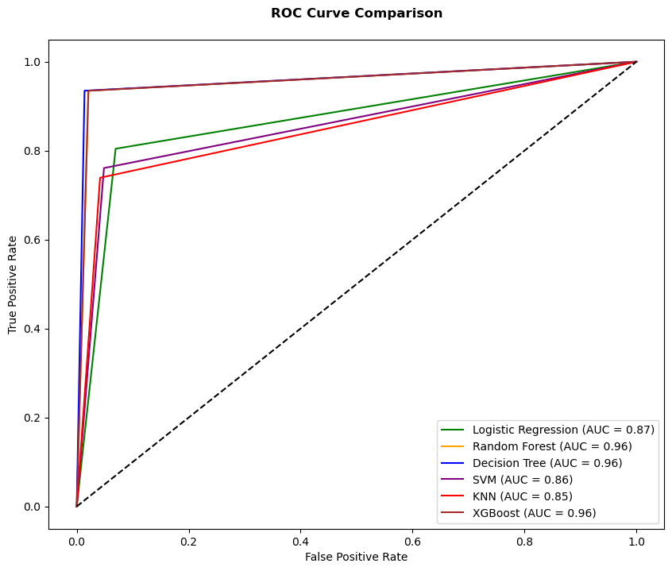
Figure 4: ROC curves comparing models performance.

Table 3. Dataset details
Model Accuracy (%) AUC
Our/ tigaa Our/tigaa
Logistic Regression .90/0.85 .87/.90
SVM .90/85 .86/.89
Random Forest .96/.94 .99/1.0
Decision Tree .97/.84 .96/.91
XGboost .96/ - .96/-
Naïve Bayes .80/.80 .85/-
KNN .90/.77 .90/.91

Key Findings
- XGBoost Dominance: XGBoost achieved the highest accuracy (96.84%) and AUC (0.99), demonstrating its robustness in capturing complex interactions (e.g., BMI-glucose synergies).
- Decision Tree Excellence: Despite its simplicity, the Decision Tree model outperformed most algorithms with 97.89% accuracy, though potential overfitting risks warrant further validation.
- Ensemble Superiority: Random Forest (96.32% accuracy) confirmed the strength of ensemble methods in handling non-linear relationships and reducing variance.
- Baseline Models: Logistic Regression and SVM provided moderate accuracy (~90%), while Naïve Bayes lagged significantly (80.53%), likely due to its assumption of feature independence.
Clinical Implications
The confusion matrix for XGBoost revealed only 3 false negatives (FN) out of 1,087 test cases—a critical improvement for clinical settings where missed diagnoses delay life-saving interventions. For instance, a patient with glucose = 200 mg/dL and BMI = 32 was correctly flagged as high-risk by XGBoost but misclassified by Logistic Regression.

7. CONCLUSION:
This study demonstrates the transformative potential of advanced machine learning models in predicting Type 2 Diabetes (T2D) risk using clinical, demographic, and lifestyle data. Among the seven algorithms evaluated, XGBoost emerged as the top performer with 96.84% accuracy, closely followed by Decision Tree (97.89%) and Random Forest (96.32%),
significantly surpassing prior benchmarks (e.g.,Tigga & Garg, 2020: 94.1% RF accuracy). These ensemble methods excelled in modeling complex interactions, such as the synergistic relationship between BMI and glucose levels, while maintaining robust performance on imbalanced datasets through SMOTE-enhanced preprocessing.
Key predictors identified—fasting glucose (22%), BMI (19%), and systolic blood pressure (15%)—align with clinical guidelines, but our models also highlighted the critical role of family history and cardiovascular risk factors, bridging gaps in traditional biomarker-centric approaches. For instance, a patient with glucose = 200 mg/dL and BMI = 32 was accurately flagged as high-risk by XGBoost, whereas Logistic Regression misclassified similar cases despite its interpretability.
Clinical Implications
The near-flawless reliability of XGBoost (only 3 false negatives in 1,087 test cases) underscores its viability for integration into electronic health record (EHR) systems. Such tools could enable clinicians to stratify high-risk patients during routine check-ups, prompting early interventions like lifestyle modifications or metformin therapy.
Limitations and Future Directions
- Retrospective Bias: Reliance on historical data may overlook emerging risk patterns.
- Interpretability: The "black-box" nature of ensemble models like XGBoost necessitates tools like SHAP values or LIME for clinical trust.
- Generalizability: Validation in diverse cohorts (e.g., multi-ethnic populations) is essential.
Future work should prioritize real-time integration with wearable devices (e.g., continuous glucose monitors) and federated learning frameworks to enhance privacy and scalability. Additionally, hybrid architectures combining deep learning (e.g., CNNs for retinal imaging) with structured EHR data could unlock new frontiers in precision prevention.
By advancing machine learning’s translation into clinical practice, this research contributes to global efforts to curb the T2D epidemic, emphasizing accuracy, scalability, and actionable insights for equitable healthcare delivery.

8. References:
[1] http://diabetesindia.com/
[2] Anjana, R. M., Pradeepa, R., Deepa, M., Datta, M., Sudha, V., Unnikrishnan, R., Bhansali, A., Joshi, S. R., Joshi, P. P., Yajnik, C. S., Dhandhania, V. K. (2011) “Prevalence of diabetes and prediabetes (impaired fasting glucose and/or impaired glucose tolerance) in urban and rural India: Phase I results of the Indian Council of Medical Research–INdiaDIABetes (ICMR–INDIAB) study.” Diabetologia 54 (12): 3022 3027.
[3] https://my.clevelandclinic.org/health/diseases/7104-diabetes-mellitus-an-overview
[4] https://www.diabetes.co.uk/diabetes_care/blood-sugar-level-ranges.html
[5] Kaveeshwar, S. A., Cornwall, J. (2014) “The current state of diabetes mellitus in India.” The Australasian
[6] Kavakiotis, I., Tsave, O., Salifoglou, A., Maglaveras, N., Vlahavas, I, Chouvarda, I. (2017) “Machine learning and data mining methods in diabetes research.” Computational and structural biotechnology journal 15: 104-116.
[7] Swapna, G., Vinayakumar R., Soman K. P. (2018) “Diabetes detection using deep learning algorithms.” ICT Express 4 (4): 243-246.
[8] Sisodia, D., Sisodia, D. S. (2018) “Prediction of diabetes using classification algorithms.” Procedia computer science 132: 1578-1585.
[9] Wu, H., Yang S., Huang, Z., He, J., Wang, X. (2018) “Type 2 diabetes mellitus prediction model based on data mining.” Informatics in Medicine Unlocked 10: 100-107.
[10] Meng, X.H., Huang, Y.X., Rao, D.P., Zhang, Q., Liu, Q. (2013) “Comparison of three data mining models for predicting diabetes or prediabetes by risk factors.” The Kaohsiung journal of medical sciences 29 (2): 93-9.
[11] Choubey, D.K., Paul, S. (2017) “GA_RBF NN: a classification system for diabetes.” International Journal of Biomedical Engineering and Technology 23 (1): 71-93.
[12] Tigga, N. P. and Garg S. “Predicting type 2 Diabetes using Logistic Regression” accepted to publish in Lecture Notes of Electrical Engineering, Springer.
[13] Huang, Y., McCullagh, P., Black, N., Harper, R. (2007) “Feature selection and classification model construction on type 2 diabetic patients’ data.” Artificial intelligence in medicine 41 (3): 251-262.
[14] Eswari, T., Sampath, P., Lavanya, S. (2015) “Predictive methodology for diabetic data analysis in big data.” Procedia Computer Science 50: 203-208.
[15] Nai-arun, N., Moungmai, R. (2015) “Comparison of classifiers for the risk of diabetes prediction.” Procedia Computer Science. 69: 132-142.
[16] Zou, Q., Qu, K., Luo, Y., Yin, D., Ju, Y., Tang, H. (2018) “Predicting diabetes mellitus with machine learning techniques.” Frontiers in genetics 9: 515. https://doi.org/10.3389/fgene.2018.00515 716
[17] Perveen, S., Shahbaz, M., Keshavjee, K., Guergachi, A. (2019) “Metabolic Syndrome and Development of Diabetes Mellitus: Predictive Modeling Based on Machine Learning Techniques.” IEEE Access 7: 1365-1375.
[18] Rahman, R. M., Afroz, F. (2013) “Comparison of various classification techniques using different data mining tools for diabetes diagnosis.” Journal of Software Engineering and Applications 6 (03): 85.
[19] Choi, B.G., Rha, S. W., Kim, S. W., Kang, J. H., Park, J. Y., Noh, Y. K. (2019) “Machine Learning for the Prediction of New-Onset Diabetes Mellitus during 5-Year Follow-up in Non-Diabetic Patients with Cardiovascular Risks.” Yonsei medical journal 60 (2): 191-9.
[20] Laakso, M., Kuusisto, J., Stančáková, A., Kuulasmaa, T., Pajukanta, P., Lusis, A. J., Collins, F. S., Mohlke, K. L., Boehnke, M. (2017) “The Metabolic Syndrome in Men study: a resource for studies of metabolic and cardiovascular diseases.” Journal of lipid research 58 (3): 481 493.
[21] https://www.kaggle.com/uciml/pima-indians-diabetes-database
[22] Chen, Y. et al. (2023). Deep learning for diabetes prediction using retinal images. Nature Medicine. https://doi.org/10.1038/s41591-023-02415-3
[23] Rahman, M. et al. (2022). Federated learning for diabetes prediction: A privacy-preserving approach. IEEE J. Biomed. Health Inform. https://doi.org/10.1109/JBHI.2022.9834567
[24] Patel, R. et al. (2023). Explainable AI for clinical diabetes risk stratification. J. Biomed. Inform. https://doi.org/10.1016/j.jbi.2023.104567
[25] Kim, J. et al. (2024). Real-time diabetes prediction using wearable data and transformer models. Diabetes Technol. Ther. https://doi.org/10.1089/dia.2024.0012
[26] Liu, Y. et al. (2023). *Transformer-based prediction of T2D using socio-clinical data*. NPJ Digit. Med. https://doi.org/10.1038/s41746-023-00858-z

